Instructions for Exp
EXP 1-Implementation of Basic operations on stack using Array and Linked List- Create, Insert, Delete, Peek.
Implementation of Basic operations on stack using Array
Steps to be used:
- First Write functions for push, pop, display operation of stack
- Try creating a menu driven program for performing the above operations on stack by using the already created functions.(switch case concept)
(exit function can also be used ) (header files-stdlib.h to be used for exit)
- Further apply peek operation also by creating a function for it too and including it in the program.
- Paste screenshots for execution/output of each and every operation in the writeup.
Various Online C editors/IDE-
https://www.onlinegdb.com/online_c_compiler
https://www.tutorialspoint.com/compile_c_online.php
Any other link can also be used
Implementation of Basic operations on stack using Linked List
Steps to be used:
- First Write functions for push, pop, display operation of stack
- Push Operation= Inserting a node into the front or start of the list. i.e. at the top of the stack
- Pop Operation= Deleting a node pointed to by start pointer of the list. i.e. at the top of the stack
- Display Operation=Displaying all elements till the Stack pointer is NULL or stack is empty.
- Try creating a menu driven program for performing the above operations on stack by using the already created functions.(switch case concept)
(exit function can also be used ) (header files-stdlib.h to be used for exit)
- Further apply peek operation also by creating a function for it too and including it in the program.
- Paste screenshots for execution/output of each and every operation in the writeup.

STUDENT NAME: Peeth Chowdhary
ROLL NUMBER: 16010122034
CODE:
#include <stdio.h>

int top = -1;
int number_stack[10];

void push(int max){
if (top == max - 1){
printf("Stack cannot be pushed as stack is overflowing.\n");
}
else{

int value;
printf("Input value to be pushed: ");
scanf("%d", &value);
number_stack[top + 1] = value;
}
top++;
}

void pop(){
if (top == -1){
printf("Stack cannot be popped as stack is underflowing.\n");
}
else{
number_stack[top] = '\0';
top--;
}

}

void display(){
printf("Displaying all elements:\n");

for( int i = 0; number_stack[i] != '\0'; i++){
printf("%d\t", number_stack[i]);
}

printf("\n");
}

int main()
{
int max = 10;
while(1){
int option = 0;

printf("\n#############################\n");
printf("Input a number for the corresponding option you would like to execute on the stack:\n");
printf("[1] Push\n[2] Pop\n[3] Display\n[4] Exit\n");

scanf("%d", &option);

switch(option) {
case 1:
push(max);
break;
case 2:
pop();
break;
case 3:
display();
break;
case 4:
printf("Exiting out of the program.");
return 0;
default:
printf("Enter a Valid Option.");
}
}

return 0;
}

OUTPUT IMAGES:
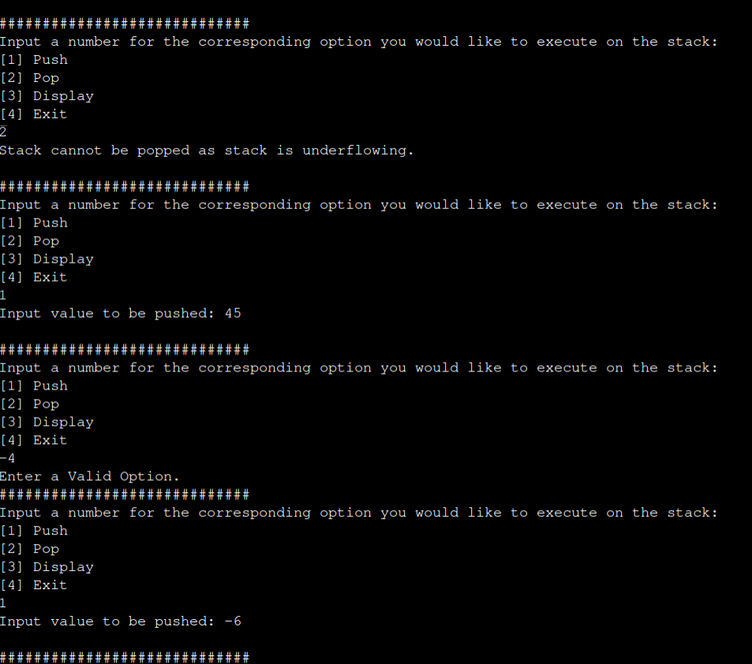
IMAGE 1 ^
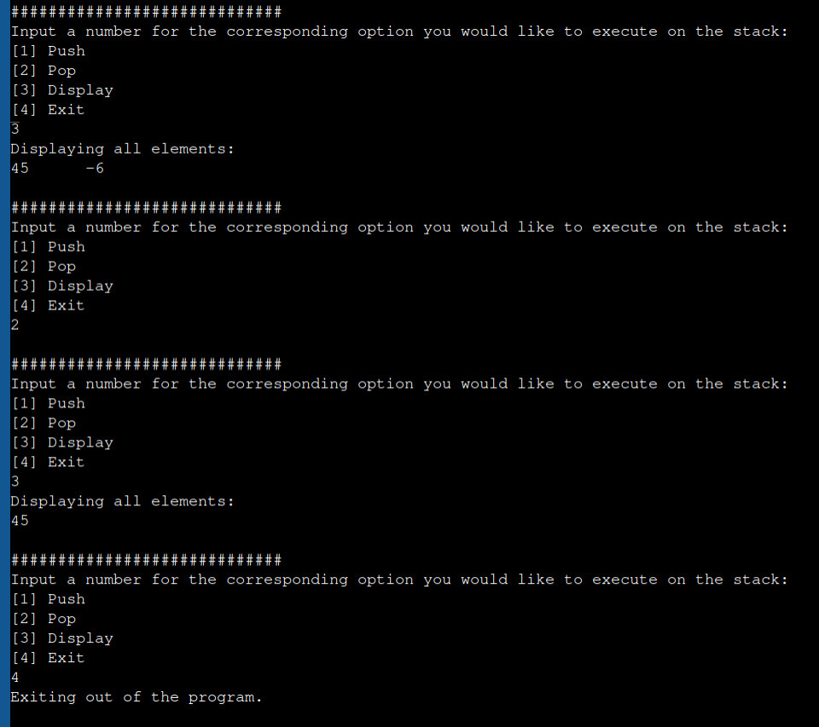
\IMAGE 2 ^

